**Pm4 tool :**

<http://etassp.de.bosch.com/default.aspx>

**SMT: Ticketing Tool ETAS :**

<https://rb-smt.de.bosch.com>

**Solution Group of SMT:**

ETAS_ICO CSG

**Mail: CI-Hotline 🡪 It is a lead of BMC REMEDY ticketing tool ( SMT Tool )**

**REPORTING SMT URL :**

[**http://ci-reporting.de.bosch.com/**](http://ci-reporting.de.bosch.com/)

**PAM Tool: login to servers :**

<https://rb-pam.bosch.com>

IT Partner (For access request):

ETAS_MB_DE IVP_FE MB_DE_IVP_FE@etas.com (mail ID)

ETAS_ICO_IVP CSG (SMT Solution)

**Softwares Install:**

Microsoft Visual Studio Team Explorer 2013

TSVN 1.10 With ETAS DMS

<http://sgpmis02.apac.bosch.com/LandingPage/>

IT Services 🡪 Request IT-Services 🡪 Software 🡪 Order / Remove 🡪 Select software 🡪 Price 🡪 Submit

**Wikipedia for SVN/TFS :**

<https://inside-docupedia.bosch.com/confluence/display/ETAS/Subversion__FAQ>

<https://inside-docupedia.bosch.com/confluence/pages/viewpage.action?pageId=253886665>

**Tortoise SVN documentation :**

<https://tortoisesvn.net/faq.html#wconshare>

**Visual SVN upgradation Document :**

<https://etasdms.de.bosch.com/!/#Departments.QMM2/view/head/30_Services/Process_Applications_PLC/55_Subversion>

**To Find the Access workflows :**

<https://rb-im.bosch.com/BOAWeb/pages/requests/search-requests.xhtml>

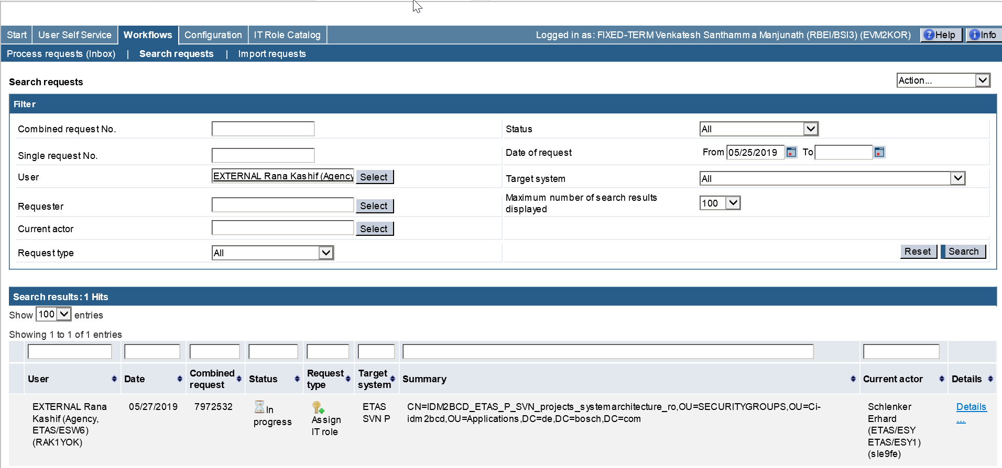

**Repositories :**

<https://inside-docupedia.bosch.com/confluence/display/ETAS/Subversion#Subversion-Repositories>

SVN repo’s

<https://inside-docupedia.bosch.com/confluence/display/ETAS/Document+Management+System#DocumentManagementSystem-PEPrelatedrepositories>

DMS repo’s